**Learning note-urban transportation networks_chapter 1**

14thMarch 2018

This book describes how the **interactions** between congestion and travel decisions can be **modeled and solved** simultaneously to obtain flow pattern throughout the urban transportation network.

**1 Urban transportation networks analysis**

one of the main problems is that of **predicting the impact of given transportation scenarios,** the analysis of which can be dealt with in two stages.

first, the scenario is specified mathematically as **a set of inputs** that are used to predict the **flow pattern** through each component of the urban network. flow is measured in terms of the number of travel units(vehicles, passengers, pedestrians) that traverse a given transportation facility in a unite time.

the relationship between flow, congestion and travel decisions is:

suppress

travel decisions

flow

congestion

promote

promote

figure 1.1.1 the relationship between flow, congestion and travel decisions

the **inputs** include a description of the following:

1. the transportation **infrastructure and services**, including streets, intersections, and transit lines.

2.the transportation system operating and controlling **policies**.

3.the **demand for travel**, including the activity and land-use patterns.

second, the flow pattern is used to calculate an array of **measures** that characterize the scenario under study, which may include the following:

1.**level of service** measures, such as travel time and travel costs.--users

2.**operating characteristics**. such as revenues and profit.--operators

3.flow **by-products**. such as pollution and changes in land values.--environment

4.**welfare** measures. such as accessibility and equity.--population groups.

**conclusion:** the analysis process of predicting the impact of a given scenario is as follows:

calculate

predict

the flow pattern through each component

the measures characterizing the scenario

inputs describing the given scenario

figure 1.1.2 the analysis process of predicting the impact of a given scenario

The focus of this book is on the first stage. It just describe how individuals travel through an urban transportation system, does not provide optimal measures. as shown in figure1.1.1, since trips will be discouraged by the increasing congestion with the flow, this interaction is an **equilibrium** **between congestion and travel decisions**. At the equilibrium point, the number of trips reach a maximization.

this chapter introduces the notion of equilibrium in the context of urban transportation analysis.

**1.1 Equilibrium analysis of transportation systems**

this section presents equilibrium in general terms, and contrasts it with economic equilibrium framework. the concept of equilibrium is analyzed from the system-oriented view, which can be reflected:

(1)the need for the system-based approach to the analysis of urban transportation

(2)the general notion of equilibrium and the various type of equilibria.

(3)the application of notions to transportation system analysis.

**systems approach to urban transportation**

this section explains the reasons why the **system-based approach** is used to analysis urban transportation. the first reason is the change of any component in the urban transportation system may cause changes in other component, just isolating one component to analysis being so unilateral and inaccurate. the second reason is that the equilibrium flow pattern that would prevail under each scenario can be found only by analyzing simultaneously all elements of the urban transportation network.

**equilibrium in markets**

**equilibrium in economic market** is shown as figure 1.1.3.the pointis the equilibrium point by the market force. the price is the ''market clearing'' price. the product produced just be consumed completely .when other elements except for price associated with this economic activity change, the supply or demand curves will also change.

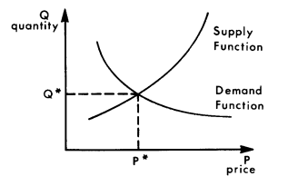

figure 1.1.3 equilibrium in economic market

another example is the performance function take an example of gas station, which depicts the **delay** associated with **queueing** shown as figure 1.1.4. the equilibrium point is .when other elements associated change, the performance or demand curve will change also.

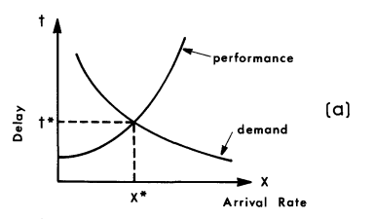

figure 1.1.4 equilibrium arrival time and arrival rate

**the transportation arena**

in transportation market, the transportation products are described by **the level of service**, such as travel time, travel costs, schedule convenience etc. many of the components of transportation **level of service are flow dependent**. the variation between level of service and flow is as figure 1.1.5.

flow

service level

congestion

change mode choice

change timing of trips

forgo the trip

figure 1.1.5 the variation of service level depended on flow

the **equilibrium** between level of service and volume is shown as figure 1.1.6.

S

level of service





volume

demand

performance

V

figure 1.1.6 the equilibrium between level of service and volume

the focus of this book is on the calculation of the **demand/performance equilibrium** in the urban passenger transportation market.

**1.2 Network representation**

the mathematical definition of a network concludes a set of **nodes**( or vertices or points) and a set of **links**( or arcs or edges) connecting this nodes, which is shown as figure 1.2.1. this text deals with extensively **directed and connected networks**. each network links associated with some **impedance** that affects the flow using it.

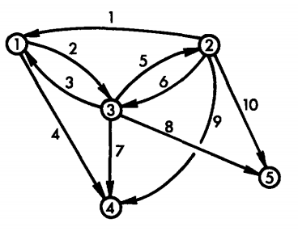

figure 1.2.1 directed network of links and nodes

**representation of the urban road network**

the roadway network concludes **intersections** and **streets,** which can be represented by **nodes** and **links** respectively. a particularly **impedance** measure for links representing urban streets is **time.** for example:

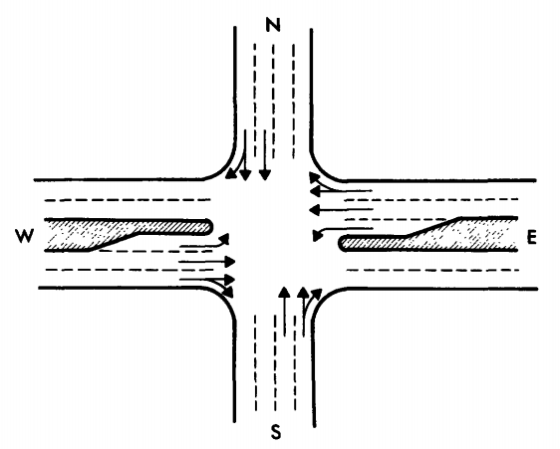 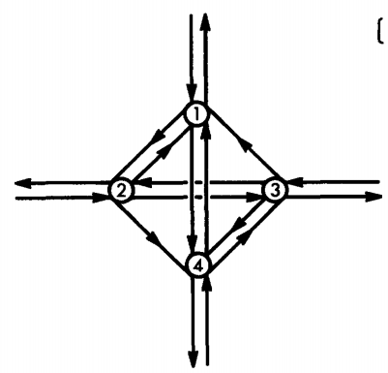

(a)intersection layout (b)intersection representation

figure 1.2.2 the representation of the urban road network

**representation of the transit network**

in the transit network, the **transit stations** (or bus stops)is represented by the **nodes** and the **line-haul portion** by **links**, which is shown in figure 1.2.3. the **impedance** on each of links include **travel time**, waiting time at the station ,the fare charged etc. the impedance on all of the network links has to be expressed in the same units.

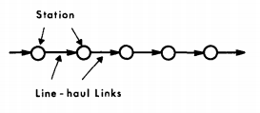

(a) representation including only the 'in-vehicle' movement

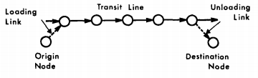

(b)a representation including boarding and alighting movements

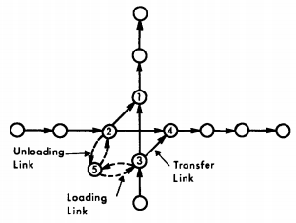

(c) a transit station, including transfer, boarding and alighting links

figure1.2.3 transit-line representation

**centroids and connect**

each **traffic zone** is represented by a node known as ***centroid***. however, not all nodes are centroid. centroids are those 'source'（源） and 'sink' (汇)nodes where traffic originates and to which traffic destinated. therefore, the movements over an urban network can be expressed in terms of ***an origin-destination matrix*** specifying the flow between every origin centroid and every destination centroid.

figure 1.2.4 shows a traffic zone surrounded by four two-way streets. the node in the middle of the zone is the centroid that is a **trip origin**, which is connected to the roadway network by special ***centroid connector*** links(known also as 'connectors' of 'dummy links'). each centroid represents an **aggregation of all actual origins and destinations**, the centroid connectors represent the **ubiquitous streets network** within a traffic zone. the analysis of the flows in the urban area **does not focus on flows within each traffic zone**. if flows in a certain zone should be analyzed , the zone under consideration should be divided into smaller zones.

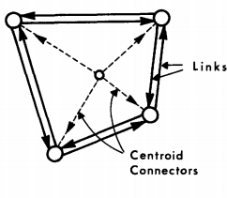

figure 1.2.4 network representation of a traffic zone, including a centroid node and centroid connnector links

**the performance function**

the primary component of impedance is travel time. this book take travel time as a combined impedance. a performance function associates with each links. a typical performance function for links is shown as figure 1.2.5. the function captures the time spent in traveling along the approach and the delay at intersection. however, the centroid **connectors** are modeled as fixed travel-time links, and **loading and unloading links** represent time and cost, both of which **do not vary with the flow**.

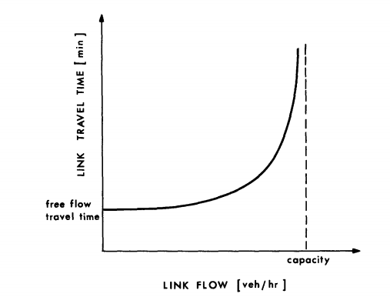

figure 1.2.5 typical link performance function for an approach to a signalized intersection

**1.3 Equilibrium over urban transportation networks**

the **performance function** is defined independently for each **link**, and the **demand function** is decided by the **motorists' behavior.** the motorists' behavior of choice for paths will affect the performance of each link, in turn, the performance of each link will also affect the motorists' behavior. therefore, no link, path or O-D pair can be analyzed in isolation no other than in **system-based**.

this section discusses the **route choice rule** and the associated **definitions of equilibrium**.

**definitions of equilibria**

the basic equilibrium problem is ***traffic assignment***. the problem can be put as follows:

1.a graph representation of the urban transportation network

2.the associated link performance functions

3.an origin-destination matrix

find the **flow** and **travel time** on each of the network links.

the most important to solve the traffic assignment problem is to find the **rule** that travelers choose paths. the choice rule of travelers for paths affect the flows on each path , in turn the flows will affect the performance of each link, and link performance affect the travelers' choice. this also is a circulation problem, so the crucial point is to find the equilibrium.

assumption 1:every motorist will try to **minimize his or her own travel time**.

assumption 2:every motorist know the travel time on every possible route and make the correct dicisions.

***the user-equilibrium (UE)***condition is a stable condition ***when no traveler can improve his travel time by unilaterally changing routes.***

however, the assumption 2 is unrealistic. in reality, motorist perceive a travel time for each path according to his own judgement depend on information he perceived. that is, every motorist may perceive a different travel time over the same link. therefore, the ***stochastic-user-equilibrium (SUE)*** *i*s proposed. ***in that case, no traveler believes that his travel time can be improved by unilaterally changing routes. this section discusses the ueser-equilibrium.***

**about study time period.** an important point is that travel demand is not uniform throughout the day. **steady-state equilibrium analyses are applicable the flows can be considered stable over the period of analysis.** therefore, certain time periods can be analyzed such as 'morning peak', 'evening peak', or 'midday'. the period of analysis has to be appreciably longer than the typical duration of trips at this time.

**a simple user-equilibrium example**

consider the two-link network shown in 1.3.1. ,represent the travel time on links1 and 2, respectively. ,represent the traffic flow on links 1and 2,reprectively. is the total O-D flow, where



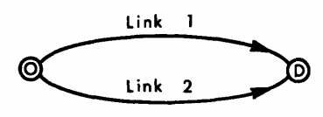

figure 1.3.1 two-link network

the performance function on these links and are shown in figure1.3.2.is the flow that causes the travel time on link 1 to equal the free-flow travel time on link 2.

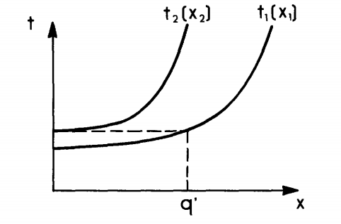

figure 1.3.2 the two performance functions

①when , the travel time on link 1 less than link 2, so all motorists choose link 1 and no one choose link 2.

②when , an additional motorist may choose each link. if the additional motorist choose link 2, the travel time on it will increase and the next choose link 1, vice versa.

③when , both links are used and maintains equilibrium. if the travel time are not equal, some motorists can change their route to lower the travel time until travel time on two links being equal, finally, equilibrium is recovered.

an operational **definition of user equilibrium** over transportation network: ***for each O-D pair, the travel time on all used paths is equal, and less than or equal to the travel time that would be experienced by a single vehicle on any unused paths.(wardrop 第一原理）***

using this definition, if the equilibrium travel time is known, the corresponding flow on each link can be determined by performance functions or performance curves as shown in figure 1.3.3. the problem then is to determine .

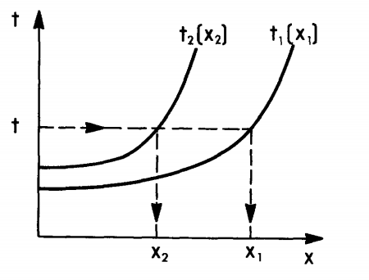

figure 1.3.3 the travel time on both links is equal if the flow is higher than 

the equilibrium travel time can be determined by creating a new 'performance curve' which depicts the O-D travel time as a function as O-D flow. the equilibrium travel time ,the flows on the individual links can be determined simply by entering the performance function with the O-D flow.

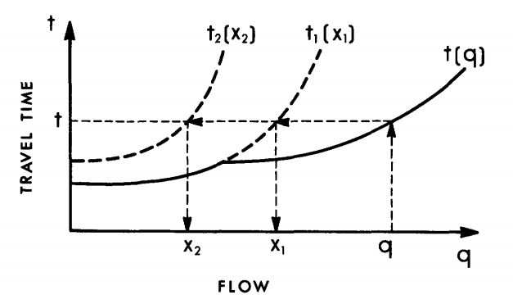

figure 1.3.4 the O-D performance function 

however, the graphical method cannot be used to solve large networks, because the flow traversing each link results from the assignment of trips between many origins and destinations. consequently, the entire network has to be solved simultaneously.

**1.4 Summary**

the problem addressed in this book based on such a background, on the one hand, the **network** which concludes physical dimensions, control strategies and operations is **fixed**. on the other hand, the **pattern of activities** that generates trips is **constant**.

the **equilibrium** discussed here is between **performance** and **demand**, unlike economic equilibrium between demand and supply. th**e equilibrium flows** and **travel times** throughout the network should be **determined simultaneously** based on a system-based analysis.

in the urban transportation network, each **link** is associated with single **flow variable** and a measure of **travel time**, the nodes are not associated with any of them.

**user equilibrium** assumes that all the motorists know the link travel times with certainty, but the **stochastic user equilibrium** models based on the assumption that each motorists may perceive a different travel time and act accordingly.